

## VISVESVARAYA TECHNOLOGICAL UNIVERSITY

**“JNANA SANGAMA” , BELAGAVI-590018, KARNATAKA**



**A Mini Project Report On**

S

***“WIN-WALK”***

**Submitted in the partial fulfillment of the requirement for the completion of Web Technology Laboratory with Mini Project (17CSL77) and award of degree of**

###### BACHELOR OF ENGINEERING IN

**COMPUTER SCIENCE AND ENGINEERING**

**Submitted By**

**Rakesh M R 1VA17CS040**

**B G Vinayak 1VA17CS010**

**Under the Guidance of**

**Mr. Nagamahesh B S Mrs. Sreelatha P K**

**Assistant Professor Assistant Professor**

**Dept. of CSE, SVIT Dept. of CSE, SVIT**

**DEPARTMENT OF COMPUTER SCIENCE AND ENGINEERING**

**SAI VIDYA INSTITUTE OF TECHNOLOGY**

**(Affiliated to Visvesvaraya Technological University, Belagavi | Recognized by Govt. of Karnataka | Approved by AICTE, New Delhi)**

**RAJANUKUNTE, BENGALURU – 560 064**

**2020-21**

S

SAI VIDYA INSTITUTE OF TECHNOLOGY

**Rajanukunte, Bengaluru- 560 064**

###### DEPARTMENT OF COMPUTER SCIENCE AND ENGINEERING



CERTIFICATE

Certified that the Mini project work entitled *“****WIN-WALK****”* carried out by **Mr. Rakesh M R (1VA17CS040), Mr. B G Vinayak (1VA17CS010),** bonafide students of **SAI VIDYA INSTITUTE OF TECHNOLOGY**, Bengaluru, in partial fulfillment for the award of Bachelor of Engineering in Computer Science and Engineering of **VISVESVARAYA TECHNOLOGICAL UNIVERSITY**, Belagavi during the year **2020-21.** It is certified that all corrections/suggestions indicated for Internal Assessment have been incorporated in the report deposited in the departmental library. The project report has been approved as it satisfies the academic requirements in respect of mini Project work prescribed for the **Web Technology Laboratory with Mini Project (17CSL77).**

**Mr. Nagamahesh B S** Assistant Professor, Dept. of CS&E, SVIT

**Dr. Archana R A**

HOD

Dept. of CS&E, SVIT

**Dr. H S Ramesh Babu**

Principal



**External Viva:**

**Name Signature**

**1.**

**2.**



**ABSTRACT**

Win-Walk is a web-based project. This project aims to build an online community, to collaborate with like-minded people and to create awareness about physical and mental health.

Fitness is certainly a solo phenomenon; however, efficiency and consistency are increased ten-folds when it has a sense of community. The community provides us a sense of belonging which keeps us motivated to achieve personal fitness goals.

This soul reason brought us the idea of creating a community of people who share a common interest in physical fitness and mental health. We live in an era of absolute uncertainty. What we can promise ourselves is a healthy life. Just taking 30 min of our time out today to be fit is all it takes to build a strong and healthy tomorrow.



The completion of the mini project brings with a sense of satisfaction, but it is never complete without thanking the persons who are all responsible for its successful completion. First and foremost I wish to express our deep sincere feelings of gratitude to my Institution, **Sai Vidya Institute of Technology**, for providing us an opportunity to do our education.

I would like to thank the **Management**, **Prof. M R Holla,** Director, Sai Vidya Institute of Technology and **Prof. A M Padma Reddy,** Director (A), Sai Vidya Institute of Technology for providing the facilities.

I extend my deep sense of sincere gratitude to **Dr. H S Ramesh Babu**, Principal, Sai Vidya Institute of Technology, Bengaluru, for having permitted to carry out the project work on “***Title of Project”*** successfully**.**

I express my heartfelt sincere gratitude to **Dr. Archana R A**, HOD, Department of Computer Science and Engineering, Sai Vidya Institute of Technology, Bengaluru, for her valuable suggestions and support.

I express my special in-depth, heartfelt, sincere gratitude to **Mr. Nagamahesh B S**, Assistant Professor, Department of Computer Science and Engineering, and **Mrs. Sreelatha P K**, Assistant Professor, Department of Computer Science and Engineering, Sai Vidya Institute of Technology, Bengaluru, for their constant support.

Finally, I would like to thank all the Teaching, Technical faculty and supporting staff members of Department of Computer Science and Engineering, Sai Vidya Institute of Technology, Bengaluru, for their support.

Student Name USN

Rakesh M R 1VA17CS040

B G Vinayak 1VA17CS010



|  |  |  |
| --- | --- | --- |
| **ABSTRACT ACKNOWLEDGEMENT LIST OF FIGURES**  **LIST OF TABLES** |  | **i ii iv v** |
| **Chapter No** | **Chapter Name** | **Page No** |
| **1** | **INTRODUCTION** | **1-7** |
| **2** | **SYSTEM REQUIREMENTS SPECIFICATION** | **8-9** |
| **3** | **SYSTEM DESIGN** | **10-12** |
| **4** | **IMPLEMENTATION** | **13-14** |
| **5** | **TESTING AND RESULTS** | **15-16** |
| **6** | **CONCLUSION** | **17** |
|  | **REFERENCE** | **18** |
| **APPENDIX A** | **SNAPSHOTS** | **19-29** |



#### LIST OF FIGURES

|  |  |  |
| --- | --- | --- |
| **Figure No** | **Title** | **Page No** |
| 1.1 | Static Web page | 1 |
| 1.2 | Code Snippet | 2 |
| 1.3 | Code Snippet Output | 3 |
| 1.4 | Dynamic Webpage | 5 |
| 3.1 | Web server architecture | 10 |
| 3.2 | Notations for ER Diagrams | 11 |
| 3.3 | ER Diagram of win-walk System | 11 |
| 3.4 | Schema Diagram | 12 |
| 6.1 | Home Page part-1 | 19 |
| 6.2 | Home Page part-2 | 20 |
| 6.3 | Post Page | 21 |
| 6.4 | User Sign-Up Page | 22 |
| 6.5 | User Sign-In Page | 22 |
| 6.6 | Forgot password page | 23 |
| 6.7 | About Us page | 23 |
| 6.8 | Contact us page | 24 |
| 6.9 | Backend Dashboard Page | 24 |
| 6.10 | All Posts Page | 25 |
| 6.11 | Add New Post Page | 25 |
| 6.12 | All Users Page | 26 |
| 6.13 | Add New User | 26 |



**LIST OF TABLES**

|  |  |  |
| --- | --- | --- |
| **Table No** | **Caption** | **Page No** |
| 5.1 | **Test cases for Admin Interface** | 15 |
| 5.2 | **Test cases for User Interface** | 16 |

**CHAPTER 1**

**INTRODUCTION**

The term web application refers to a software system that provides a user interface through a web browser. Examples of web applications include blogs, online shopping, search engines, etc.

Web applications can be simple, consisting of only static web pages or they can be dynamic and interactive. Static web pages are stored in the file system of web server usually displays the same information to all visitors. Whereas dynamic pages are constructed by a program that produce the HTML. This type of web application provide individual information to the user and let them personalize the content according to their preferences.

* 1. How the static web page work?

We already know that to open a web page we enter URL or click on link and web browser displays web page that we request. Let's discuss the steps that happen behind the scene.

* + - The user enters a URL in the browser.
    - The browser sends a request to the web server over the internet.
    - Web Server examines the request and based on the request server finds the requested page already stored in its local drive.
    - Web Server sends the response to the web client(browser).
    - Browser gets the HTML and renders it into a display for the user.

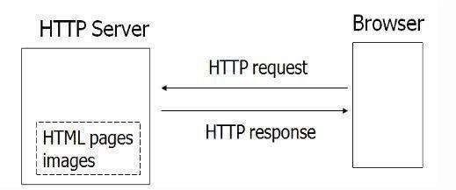

**Figure 1.1:** Static Web page

* + 1. URL (Uniform Resource Locater)

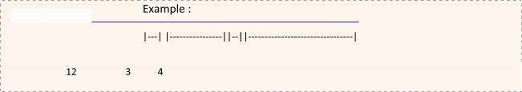You have undoubtedly used URLs to access HTML pages from the Web. An http URL may be broken down as shown below:

The first part, http, is the protocol name. It is followed by a colon (:) and two slash characters (//). The second part is the hostname of the computer on which the document resides.

The third part, which is optional, is the port number. Internet hosts have a certain number of ports. HTTP usually runs on port 80, but this is not necessary. If it is running on port 80 in the machine you named in the hostname part, then you don't need to specify a port number. If it is running on a different port, a colon (:) followed by the port number is required to point to that port.

The fourth part is the path to the document you are requesting. The path is a set of characters separated by slashes (/).

* + 1. Create Web Page using HTML

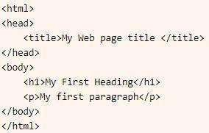With HTML, you can create your own web page. HTML is the core technology in which all pages are written. HTML use markup tags to describe web pages. You can use notepad to type HTML code. Here is an example code.

**Figure 1.2:** Code Snippet

Save this file using .html extension. When you open this file in a browser, it displays as web page. The browser does not display Html tag (Keywords surrounded by angle brackets) but use the tags to interpret the content of the page.

In previous code example,

The text between <html> and </html> describes the Web page. The text between <body> and </body> is the visible page content. The text between <h1> and </h1> is displayed as a heading.

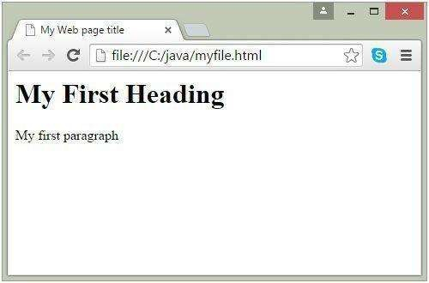The text between <p> and </p> is displayed as paragraph. Output will look like this:

**Figure 1.3:** Code Snippet Output

The following is an HTML Quick List:

Heading Element

<h1></h1>

<h2></h2>

<h3></h3>

<h4></h5>

<h6></h6>

Text Element

<p></p> paragraph

<br> line break

<hr> horizontal rule

Physical Style

<b></b> bold

<i></i> italic

Unordered (bullet) List

<ul>

<li>First Item</li>

<li>Second Item</li>

</ul>

Ordered (Number) List

<ol>

<li>First Item</li>

<li>Second Item</li>

</ol>

Tables

<table border ="1">

<tr>

<th>some heading</th>

<th>some heading</th>

</tr>

<tr>

<td>some text</td>

<td>some text</td>

</tr>

</table>

Forms

<form action="" method="post">

<p>Name:</p>

<p><input type="text" name="name" value="Your name"></p> <p>Comments: </p>

<p><textarea name="comments" rows="5" cols="20">Your comments</textarea></p> <p>Gender:</p>

<p><input type="radio" name="gender" value="male"> Male</p> <p><input type="radio" name="gender" value="female"> Female</p> <p><input type="submit"></p>

</form>

Image Element

<img src ="" />

Links

<a href ="<http://www.examples.com/>"> This is a link </a>

* 1. **How the dynamic web page work?**

Dynamic web content is the content that changes with every user request. This type of web application let the users personalize the content according to their preferences. To build such a powerful web app, you need Java technologies, like servlet, JS, and JQuery. Web Server is mostly designed to serve static HTML content.

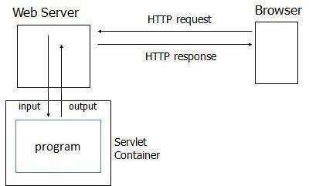

**Figure 1.4:** Dynamic Webpage

##### Storage with respect to database

According to the principles of database systems, the data is stored in such a way that it acquires lot less space as the redundant data (duplicate data) has been removed before storage. Let’s take a layman example to understand this- In a banking system, suppose a customer is having two accounts, one is saving account and another is salary account. Let’s say bank stores saving account data at one place (these places are called tables we will learn them later) and salary account data at another place, in that case if the customer information such as customer name, address etc. are stored at both places then this is just a wastage of storage (redundancy/ duplication of data), to organize the data in a better way the information should be stored at one place and both the accounts should be linked to that information somehow. The same thing we achieve in DBMS.

* + 1. **Fast Retrieval of data**: Along with storing the data in an optimized and systematic manner, it is also important that we retrieve the data quickly when needed. Database systems ensure that the data is retrieved as quickly as possible.
       - The choice of a database product is often influenced by factors such as:
       - the computing platform (i.e., hardware, operating system)
       - the volume of data to be managed
       - the number of transactions required per second
       - existing applications or interfaces that an organization may have
       - support for heterogeneous and/or distributed computing
       - cost
       - vendor support
    2. Design and Modeling:

The first task of a database designer is to produce a conceptual data model that reflects the structure of the information to be held in the database. A common approach to this is to develop an entity-relationship model, often with the aid of drawing tools. Another popular approach is the Unified Modeling Language.

A successful data model will accurately reflect the possible state of the external world being modeled: for example, if people can have more than one phone number, it will allow this information to be captured.

* 1. Objective

Fitness is certainly a solo phenomenon; however, efficiency and consistency are increased ten- folds when it has a sense of community. The community provides us a sense of belonging which keeps us motivated to achieve personal fitness goals.

This soul reason brought us the idea of creating a community of people who share a common interest in physical fitness and mental health. We live in an era of absolute uncertainty. What we can promise ourselves is a healthy life. Just taking 30 min of our time out today to be fit is all it takes to build a strong and healthy tomorrow.

* 1. Problem Statement

To build an online community, to collaborate with like-minded people and to create awareness about physical and mental health. There exists an immense lack of motivation and companionship for fitness, to overcome this there is a need for community which gives us the sense of belonging.

* 1. Scope of the report

The essential framework of this report would be to elaborate the design of E.R-diagram, Schema Diagram and to display how the functionalities of the website works in order to achieve the most of it.

#### CHAPTER 2

**SYSTEM AND SOFTWARE REQUIREMENTS AND SPECIFICATIONS**

The program works on Desktop PC and is executed using a PHP 5 interface which interacts with a MySQL database running on localhost.

* 1. **FUNCTIONAL REQUIREMENTS**

A description of the facility or feature required. Functional requirements deal with what the system should do or provide for users. They include description of the required functions, outlines of associated reports or online queries, and details of data to be held in the system.

* + 1. **Interface Requirements:**
       - Login interface (Admin & User)
       - Comment feature
       - Messaging feature
       - UI friendly admin dashboard
       - Fully dynamic & responsive website
       - Searching posts with keyword
  1. **NON-FUNCTIONAL REQUIREMENTS:**

Non-functional requirements define the overall qualities or attributes of the resulting system.

* + 1. **Usability**

Usability is the ease with which a user can use the website and get the most of it.

* + 1. **Security**

Security requirements are included in a system to ensure:

* + - * A user has to login for messaging and commenting on a post.
      * User passwords are encrypted and stored

Win-Walk

* + 1. **Reliability**

Reliability is the ability of a system to perform its required functions under stated conditions for a specific period of time. Constraints on the run-time behavior of the system can be considered under two separate headings:

* + - * Availability: is the system available for service when requested by end-users.
      * Failure rate: how often does the system fail to deliver the service as expected by end- users.
  1. **SOFTWARE REQUIREMENTS**

Programming language : PHP, MYSQL

Operating system : ANY OS (Recommended**:** Windows8,

Windows Vista, Windows XP) Application required : Standalone desktop application & Xampp Coding language : PHP, HTML, CSS, Javascript.

* 1. **HARDWARE REQUIREMENTS**

CPU : Pentium IV 2.4 GHz or above Memory (Primary) : 512 MB, 1 GB or above

Hard Disk : 40 GB or above

Monitor : 15 VGA color

#### CHAPTER: 3

**System Design**

This chapter of the report describes the structure of the project and the Use Case diagram.

* 1. **Server Architecture**

A server is a type of computer or device on a network that manages network resources. Servers are often dedicated, meaning that they perform no other tasks besides their server tasks. On multiprocessing operating systems, however, a single computer can execute several programs at once.

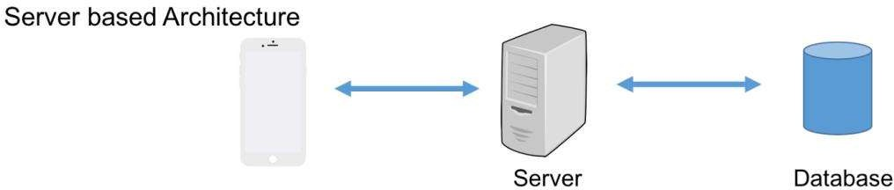

**Fig 3.1:** Web server architecture

The server in our case the server is a firebase web server. A web server is server software, or hardware dedicated to running such software, that can satisfy World Wide Web client requests. A web server can, in general, contain one or more websites. A web server processes incoming network requests over HTTP and several other related protocols.

* 1. **ER Diagram with relationships and cardinality ratio**

An entity relationship model*,* also called an entity-relationship (ER) diagram*,* is a graphical representation of entities and their relationships to each other, typically used in computing in regard to the organization of data within databases or information systems. An entity is a piece of data-an object or concept about which data is stored.

The cardinalit*y* or fundamental principle of one data aspect with respect to another is a critical feature. The relationship of one to the other must be precise and exact between each other in order to explain how each aspect links together. In simple words Cardinality is a way to define the relationship between two entities.

The following are the notations of the ER diagram:

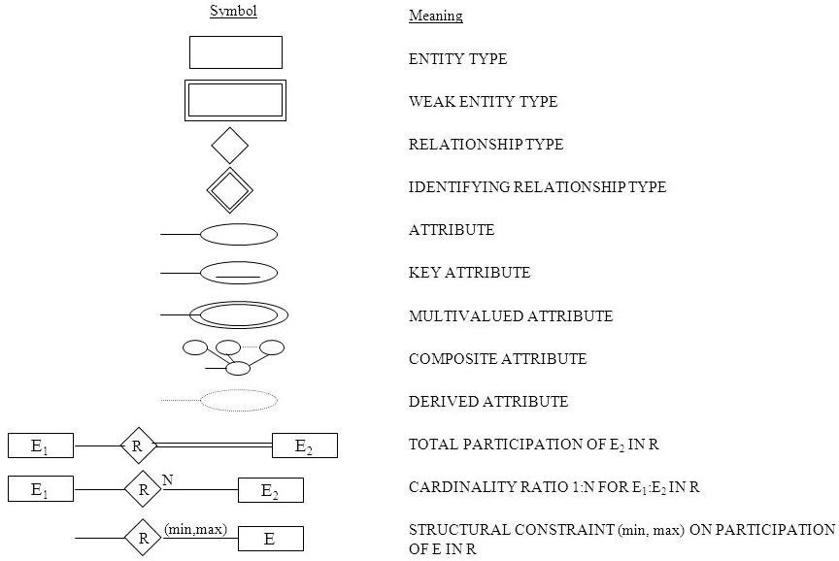

**Fig 3.1: Notations for ER Diagrams**

The ER diagram below shows the relationship between the many tables that exist in the database for the functioning of WinWalk website.

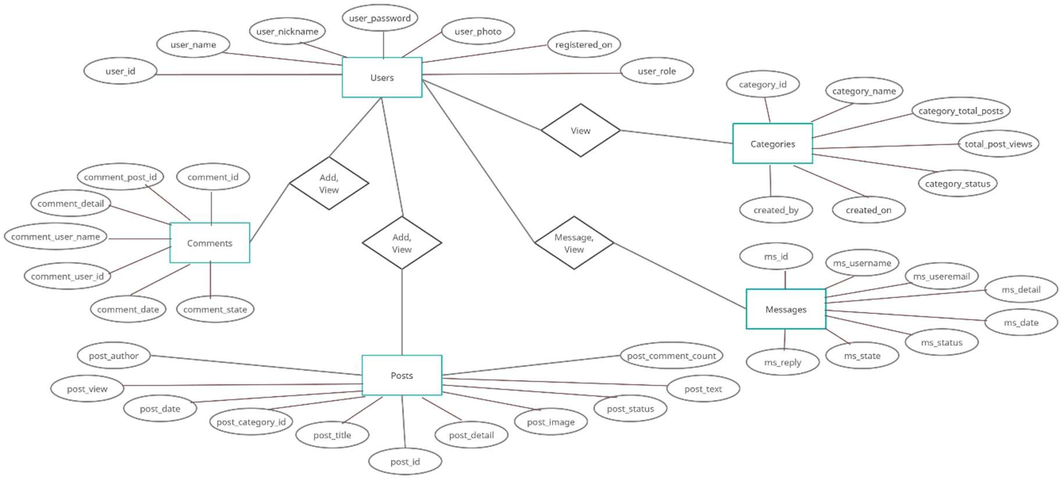

**Fig 3.2: ER Diagram of win-walk System**

* 1. **Schema Diagram**

In any data model it is important to distinguish between the description of the database and the database itself. The description of a database is called the database schema, which is specified during database design and is not expected to change frequently.

A displayed schema is called a schema diagram. A schema diagram displays only some aspects of a schema, such as the names of record types and data items, and some types of constraints.

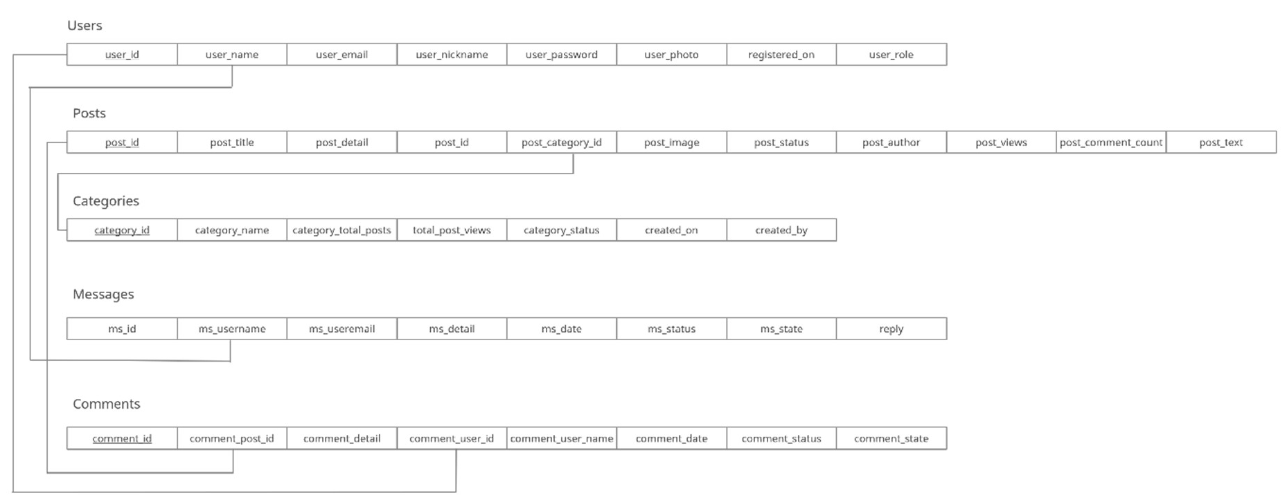

**Fig 3.3: Schema Diagram**

**CHAPTER: 4**

**IMPLEMENTATIONS**

This chapter of the report describes the Functions, packages and modules used in the project:

* 1. Libraries and Frameworks PHP

PHP is Hypertext Pre-processor is a general-purpose programming language originally designed for web development.

HTML

Hypertext Markup Language is the standard markup language for documents designed to be displayed in a web browser. It can be assisted by technologies such as Cascading Style Sheets and scripting languages such as JavaScript.

CSS

Cascading Style Sheets is a style sheet language used for describing the presentation of a document written in a markup language like HTML. CSS is a cornerstone technology of the World Wide Web, alongside HTML and JavaScript. Functional Modules

JavaScript

JavaScript, often abbreviated as JS, is a high-level, interpreted scripting language that conforms to the ECMAScript specification. JavaScript has curly-bracket syntax, dynamic typing, prototype-based object-orientation, and first-class functions.

Bootstrap

Bootstrap is a free and open-source CSS framework directed at responsive, mobile-first front-end web development. It contains CSS- and (optionally) JavaScript-based design templates for typography, forms, buttons, navigation, and other interface components.

Win-Walk

* 1. Functional Modules

The functional modules included in the project are listed below:

Insert Module:

This module provides the functionality of collecting the required data from the designed interface and transmitting it to the appropriate table present in the database designed for this project. If the provided data does not satisfy the given constraints, it must refrain from storing it into the database.

Update Module:

This module again has the functionality of collecting the data from the designed interface, but it updates the already existing tuple that matches the provided primary key of the tuple to be updated, by replacing the existing attribute values with the newly collected data. Again, if the

newly provided data does not satisfy the given constraints, it must refrain from updating the corresponding tuple.

Delete Module:

The delete counterpart is loaded with the ability to delete a single or multiple records from the table. It searches for the tuple, in the query specified table, based on the provided value for an attribute. Admin can delete in the interface, based on which delete module searches for the record corresponding to that provided attribute value and deletes the record.

Retrieve Module:

The retrieve module has a basic functionality of accessing the entire specified table from the database and displays it.

Trigger Module:

Trigger in database is set of statements that are executed after an event occurs on the specified table. This is useful for logs wherein every change in database can be logged which helps keep a track of all changes/transactions on the database.

**CHAPTER 5**

**Software Testing**

Software testing is an investigation conducted to provide stakeholders with information about the quality of the software product or service under test. Software testing can also provide an objective, independent view of the software to allow the business to appreciate and understand the risks of software implementation. Test techniques include the process of executing a program or application with the intent of finding software bugs, and verifying that the software product is fit for use.

###### Types of testing

* + 1. Functional Testing
       - Unit testing
       - Integration testing
       - System testing
    2. Non-Functional Testing
       - Performance Testing
       - Compatibility Testing
       - Reliability Testing

###### Test Cases

* + 1. **Admin Module**

**Table 5.1 : Test cases for Admin Interface**

|  |  |  |  |
| --- | --- | --- | --- |
| **Sl. No** | **Functionality** | **Comments** | **Remarks** |
| 1. | Login | Login interface for Admins | Pass |
| 2. | Dashboard functionalities | All functions in dashboard are tested | Pass |

Win-Walk

* + 1. **User Module**

**Table 5.2 : Test cases for User Interface**

|  |  |  |  |
| --- | --- | --- | --- |
| **Sl. No** | **Functionality** | **Comments** | **Remarks** |
| 1. | Login | Login interface for users | Pass |
| 2. | Sign Up | Sign Up interface for users | Pass |
| 3. | Password Reset | Password Reset Interface for user | Pass |
| 4. | Commenting | Interface for posting comments for admin post | Pass |
| 5. | Messaging | Interface to message admin personally | Pass |

### CHAPTER 6

**CONCLUSION**

The website provides a rich user interface to allow the users to have a great user experience. For implementing this system, PHP, HTML, CSS, JavaScript and MySql are used.

The system comprises of following features:

* User signup/ login.
* Commenting, messaging feature.
* Showing the posts by recent posts, most viewed and by categories.

SCOPE OF ENHANCEMENT

There are also few features which can be integrated with the system to make it more flexible.

Below list shows the future points to be considered:

* Implementing an option to share the posts on any social media.
* Making it more versatile, so that registered user can also share their posts.
* Notification for user on post posted by admin.

# REFERENCES

1. [www.w3schools.com](http://www.w3schools.com/)
2. developer.mozilla.org
3. [www.stackoverflow.com](http://www.stackoverflow.com/)
4. [www.coursera.org](http://www.coursera.org/)
5. [www.youtube.com](http://www.youtube.com/)
6. [www.wikipedia.org](http://www.wikipedia.org/)
7. [www.udemy.com](http://www.udemy.com/)

# APPENDIX A: SNAPSHOTS

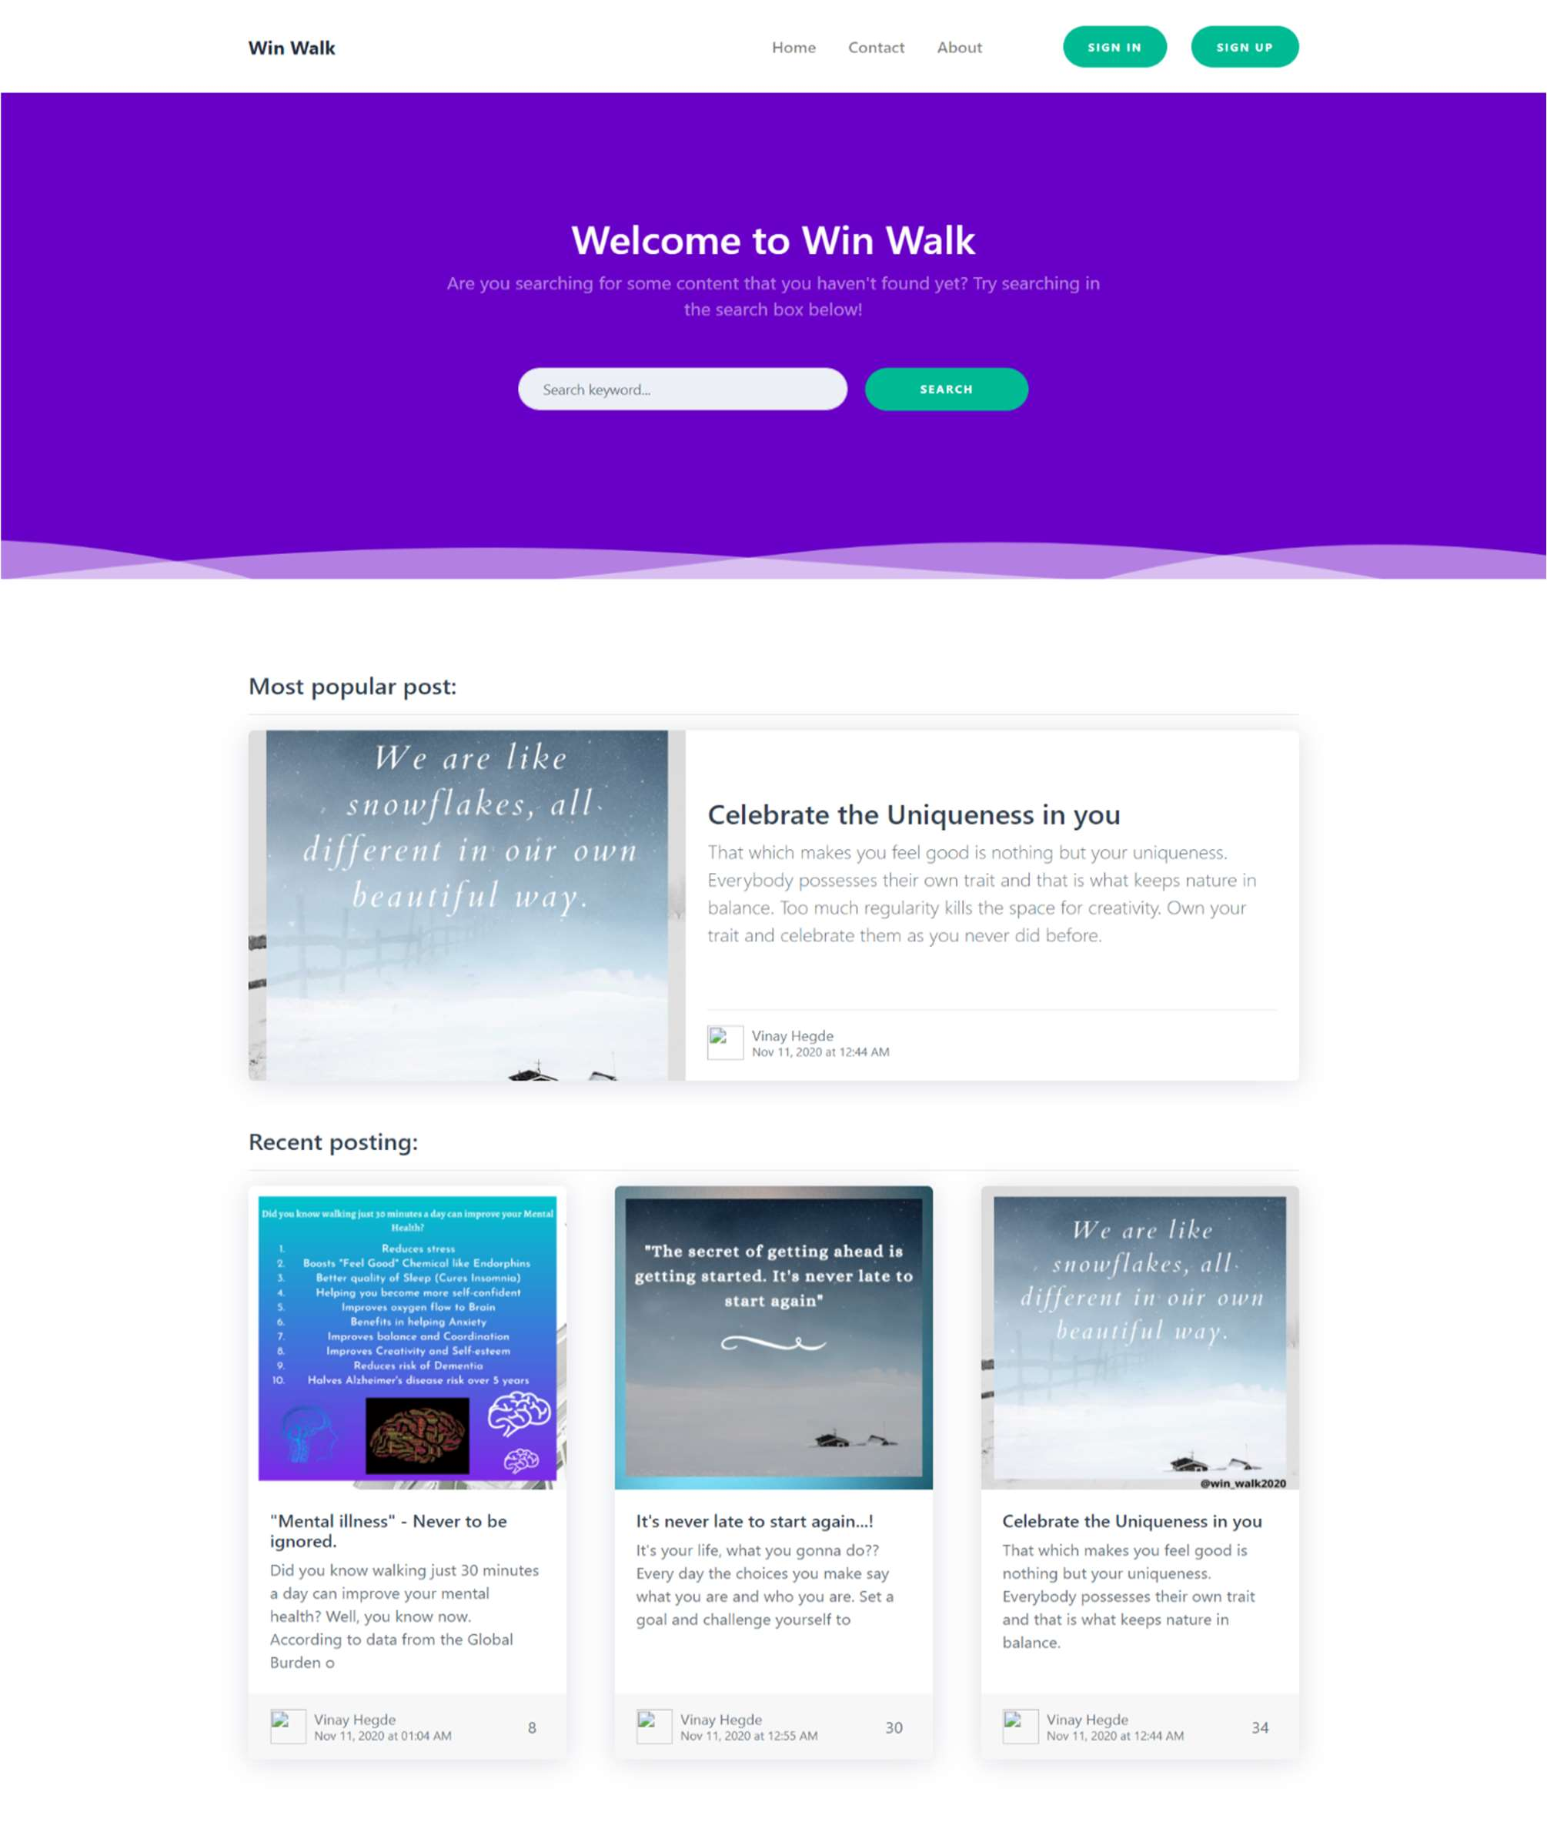

Fig 6.1 Home page - part 1

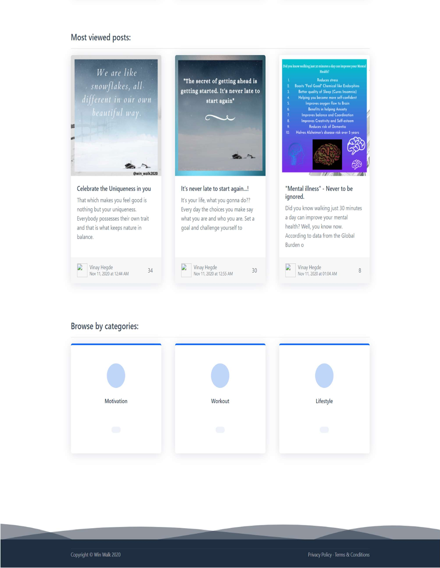

Fig 6.2 Home page - part 2

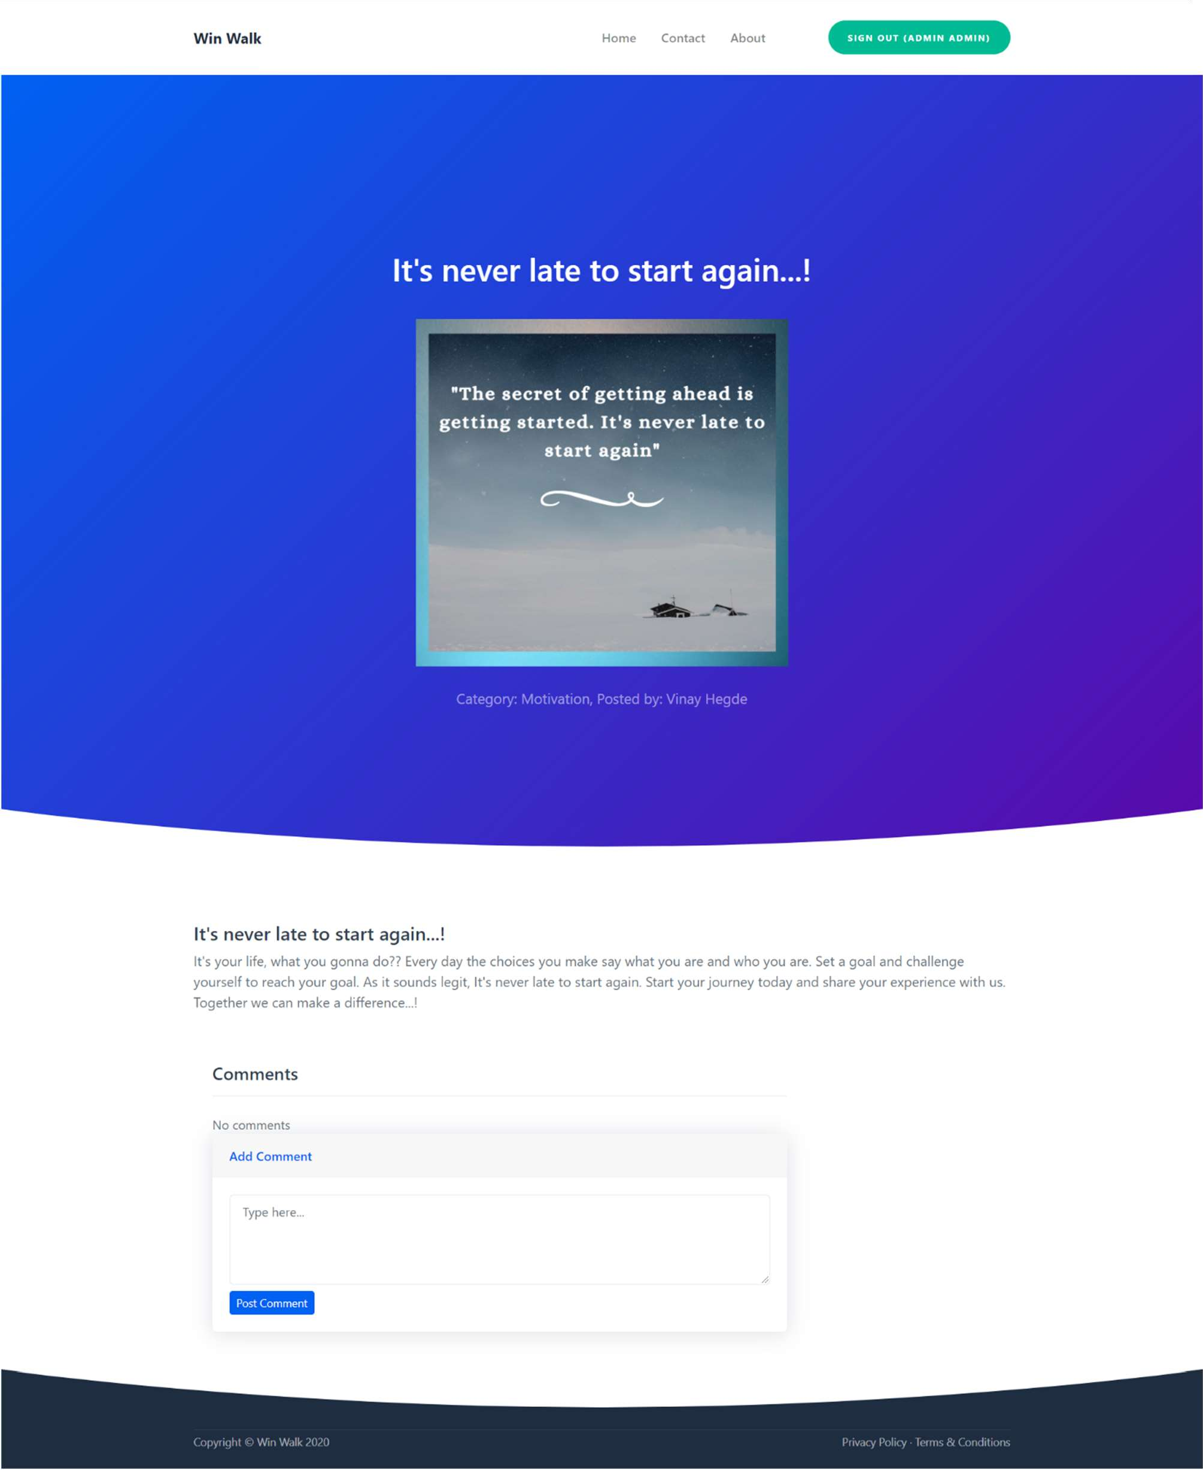

Fig 6.3 Post page

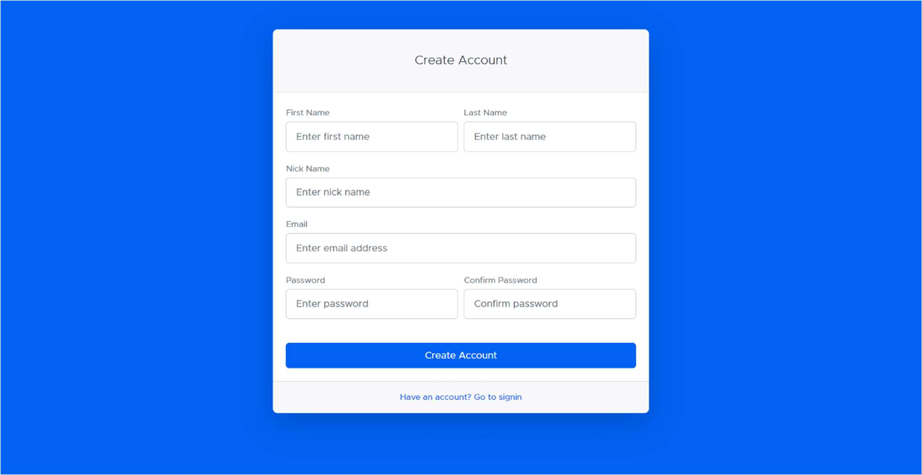

Fig 6.4 User Sign-up page

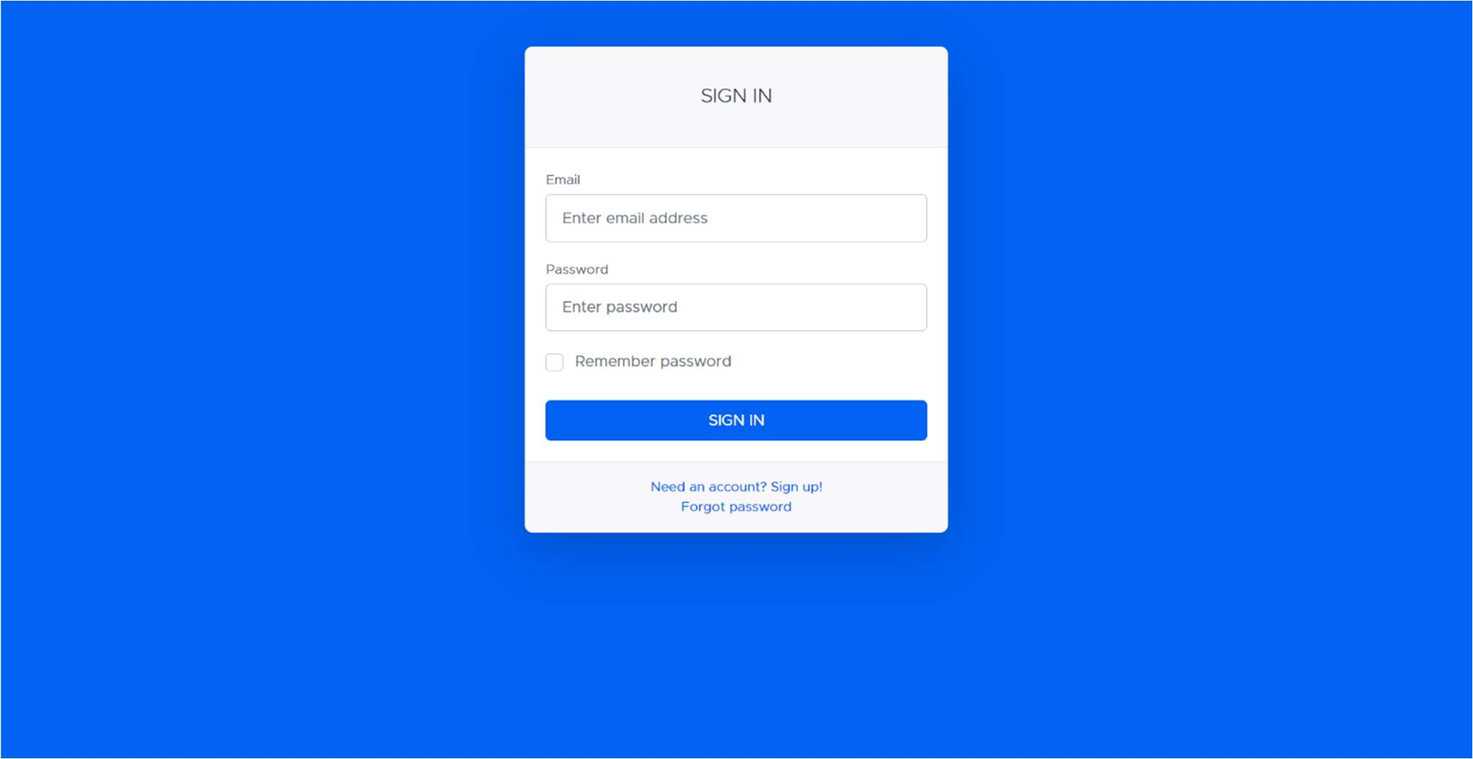

Fig 6.5 User Sign-in page

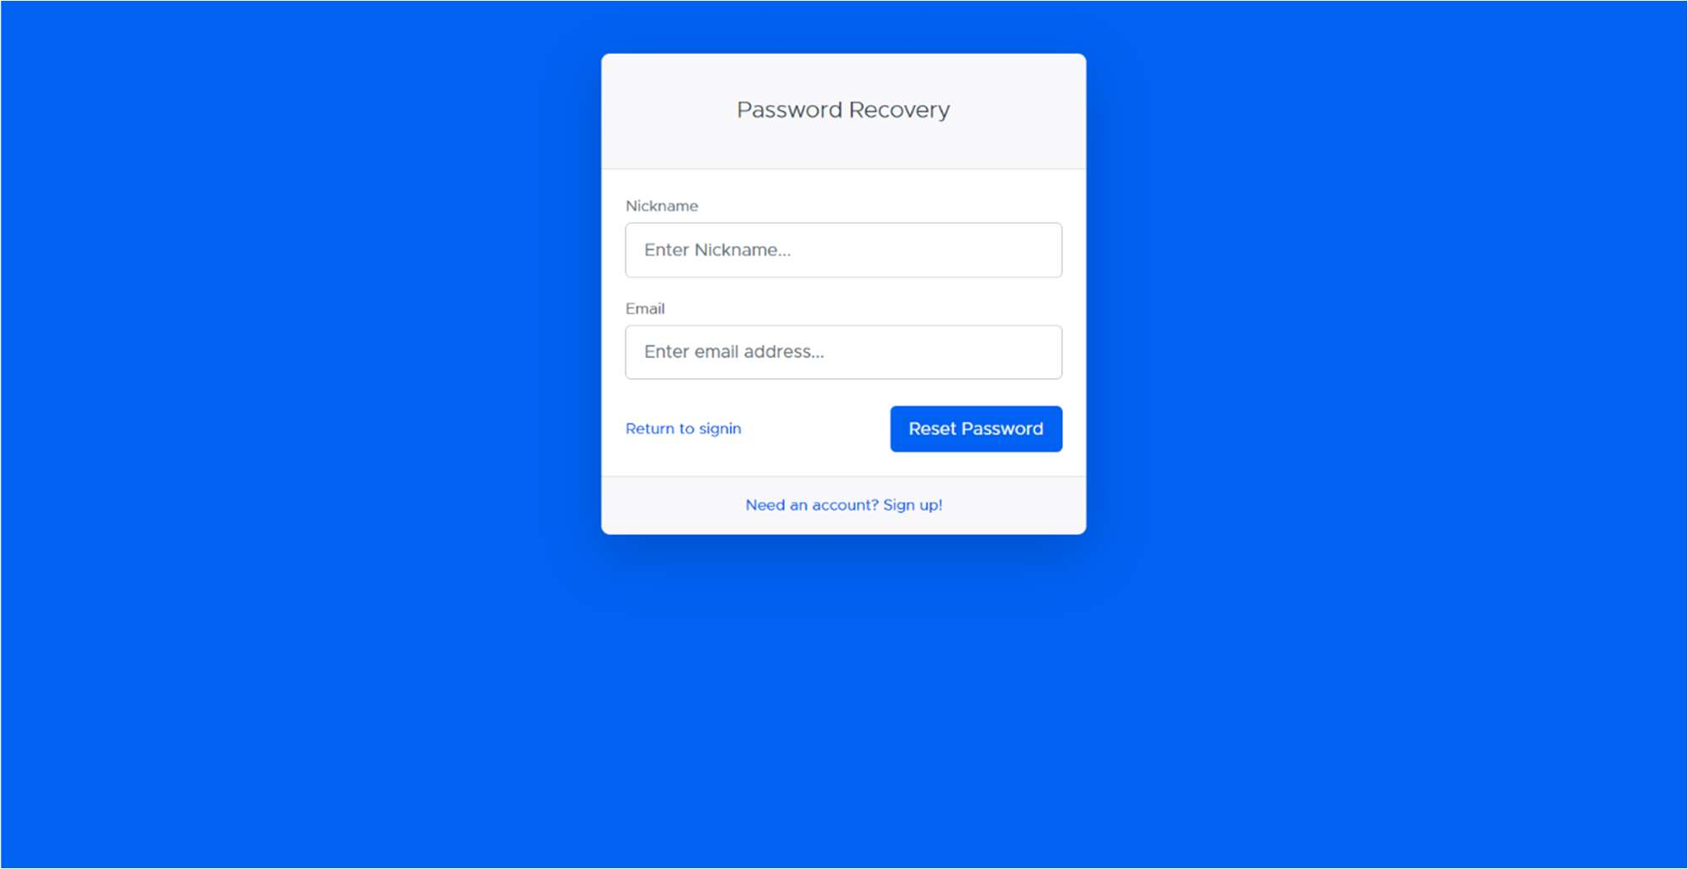

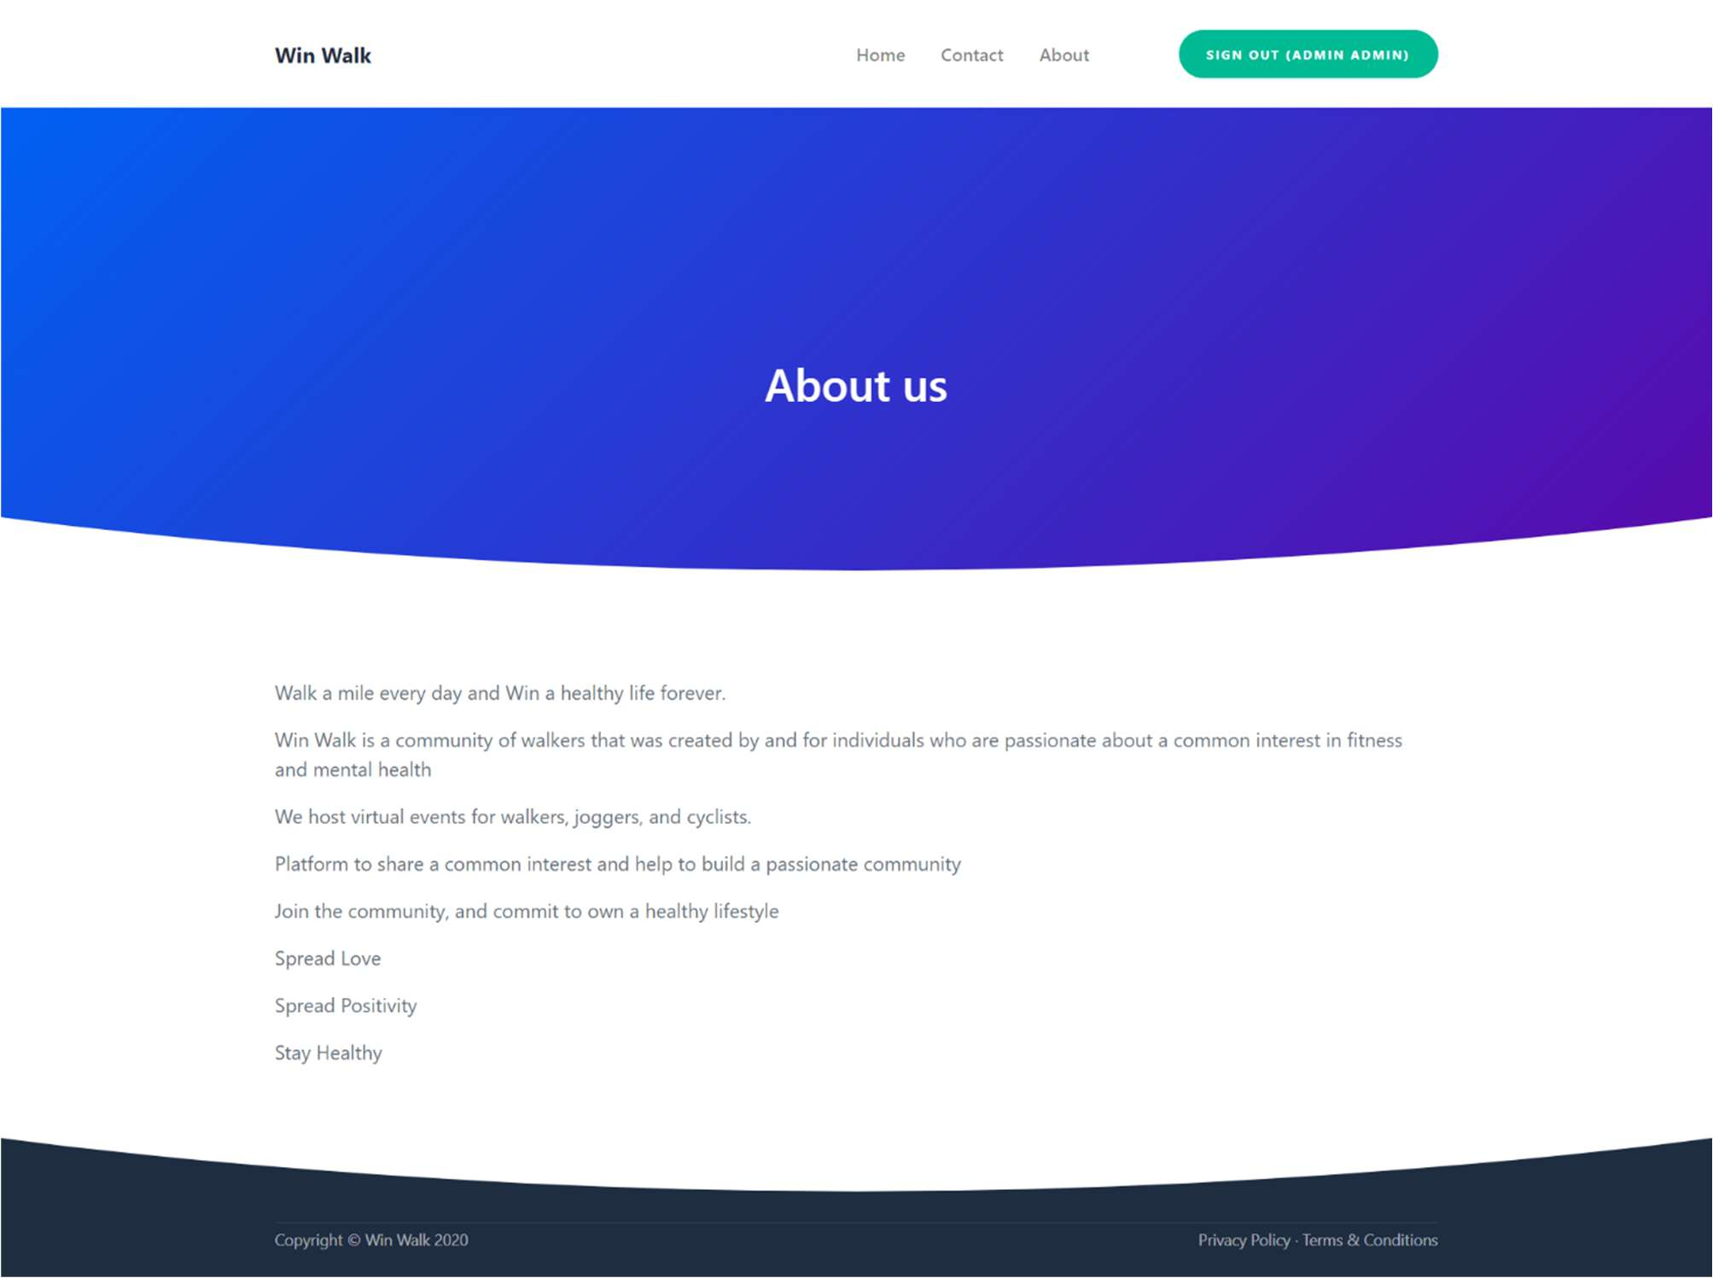Fig 6.5 Forgot password page

Fig 6.6 About us page

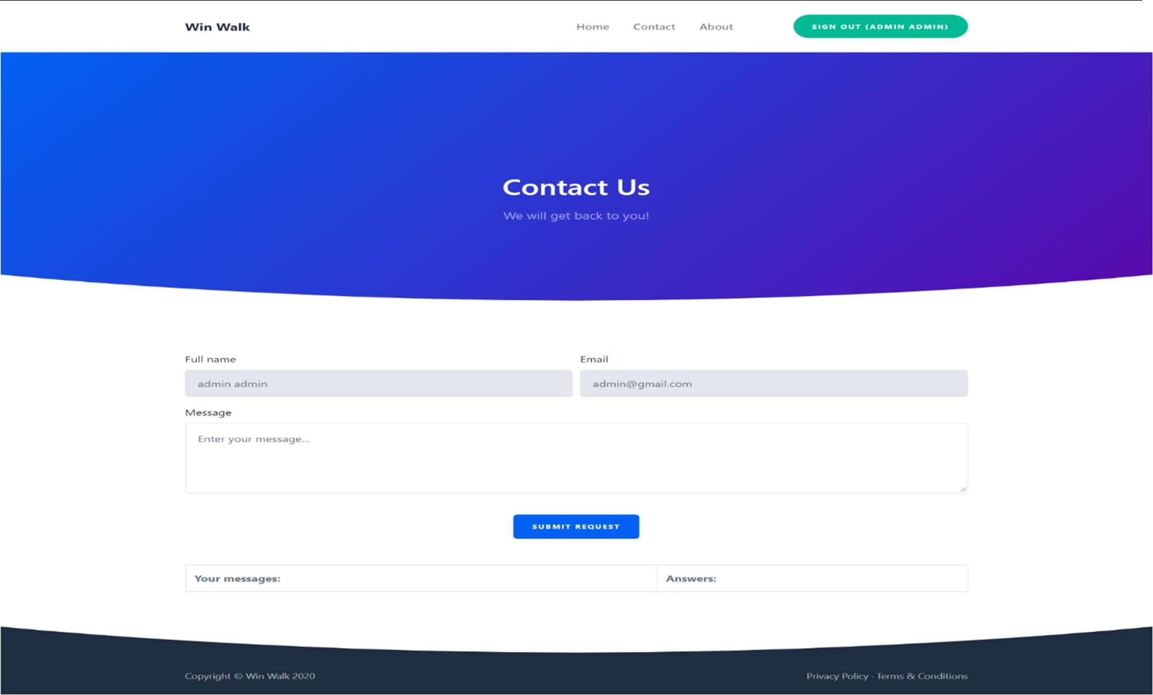

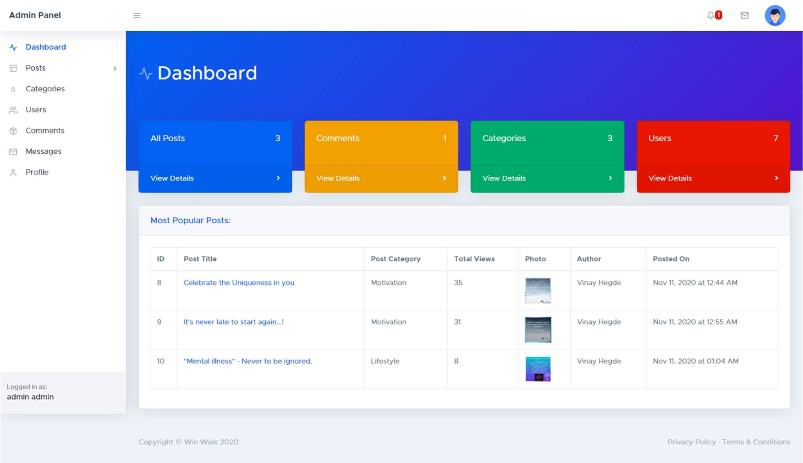Fig 6.7 Contact us page

Fig 6.8 Backend Dashboard Page

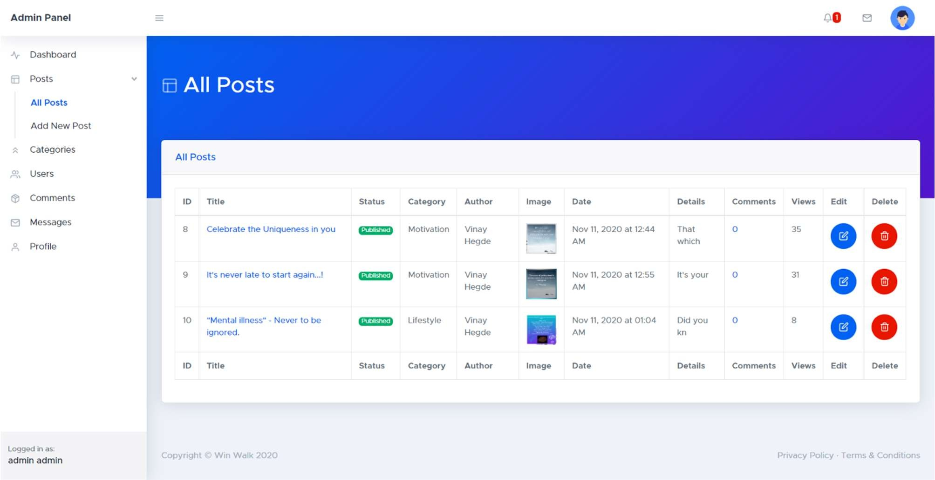

Fig 6.9 All Posts Page

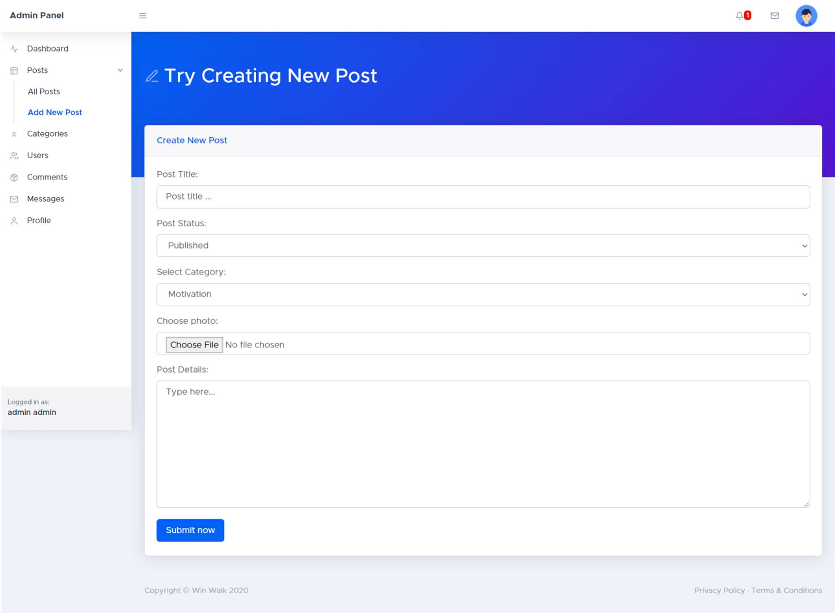

Fig 6.10 Add New Post Page

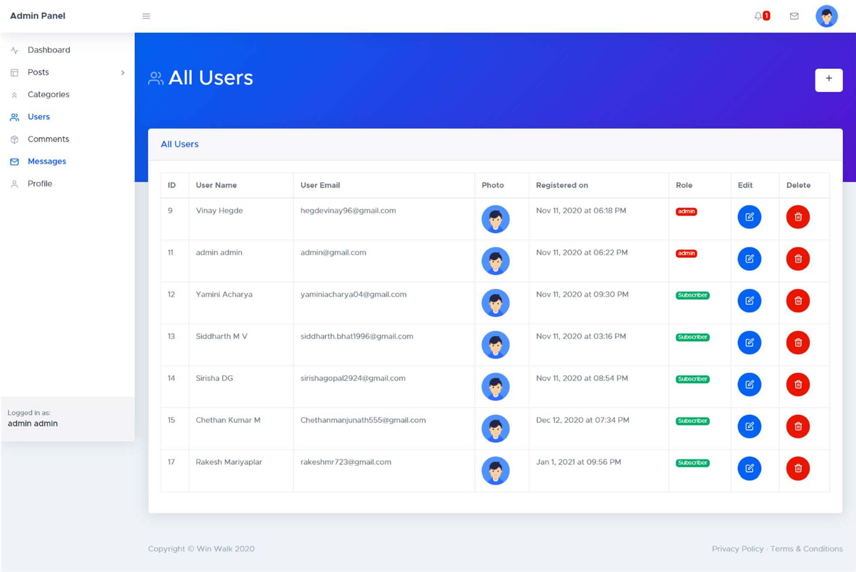

Fig 6.11 All Users Page

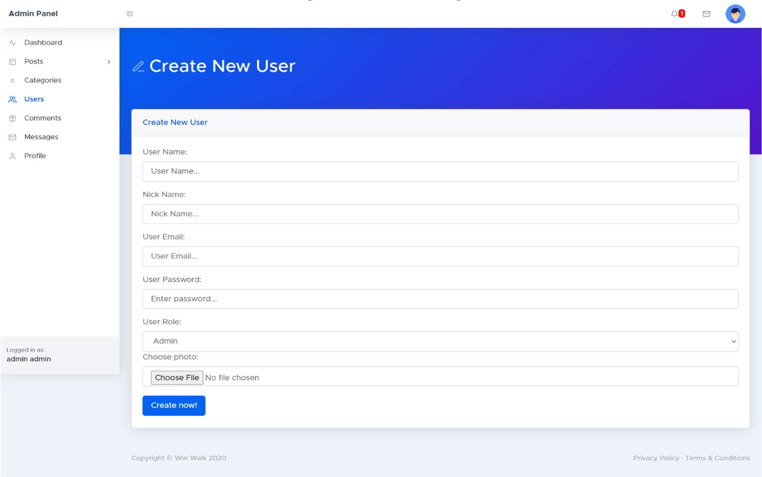

Fig 6.12 Add New User

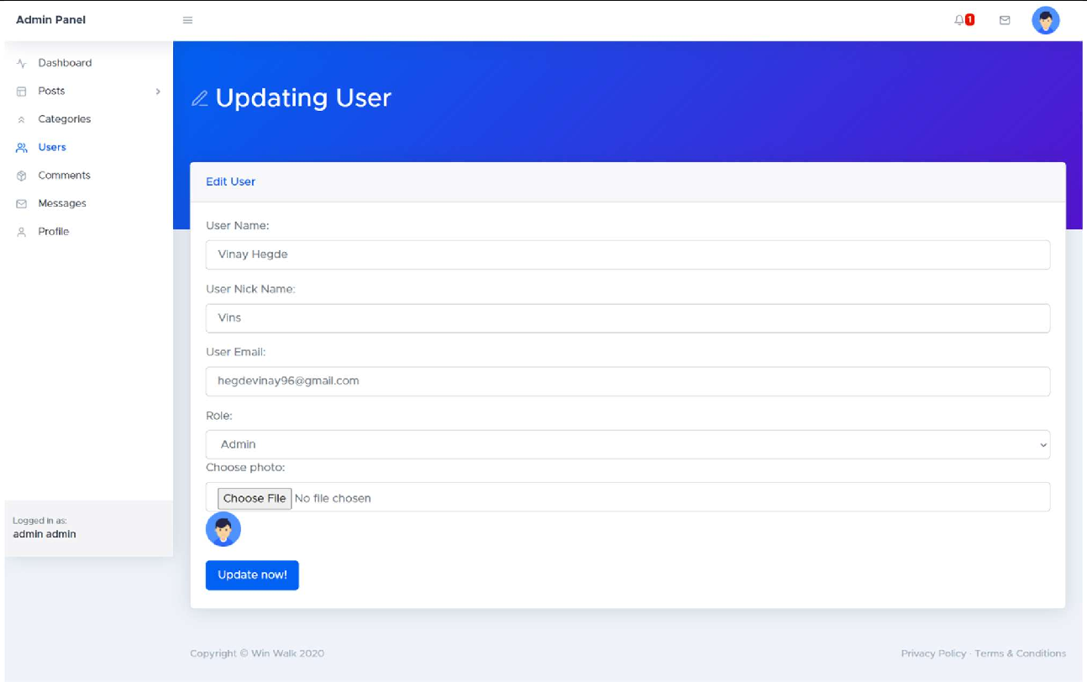

Fig 6.13 Update User

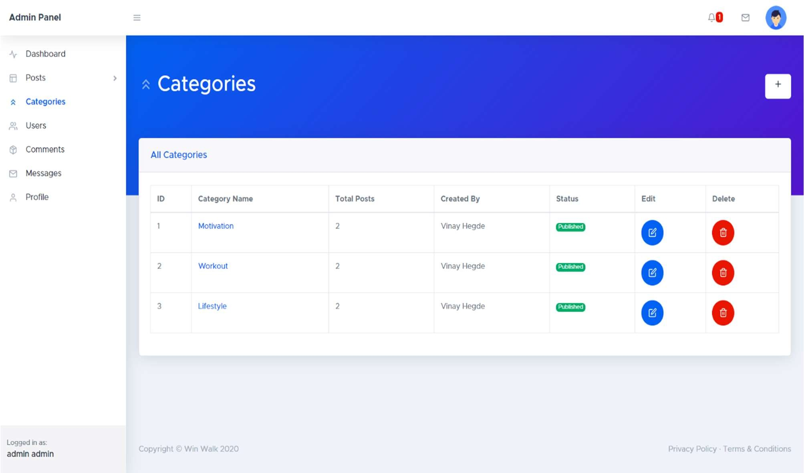

Fig 6.14 Categories

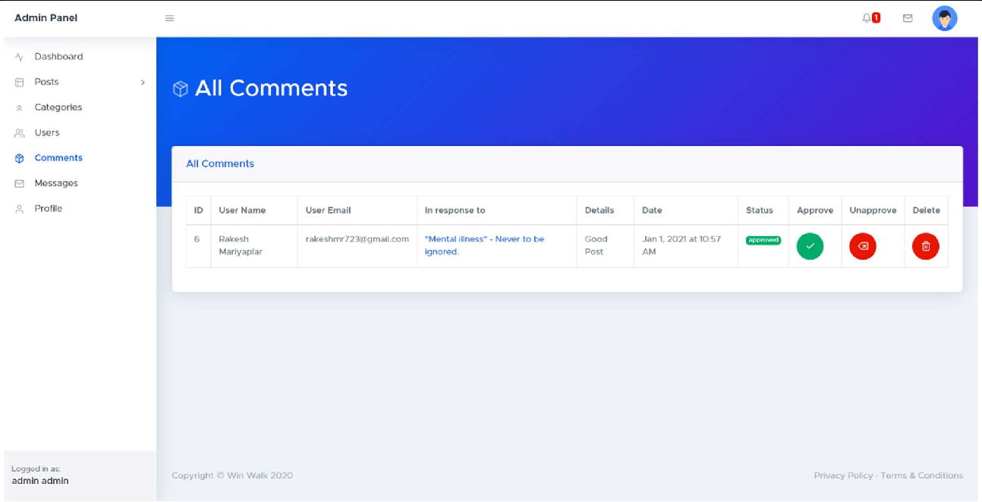

Fig 6.15 All Posts Comments

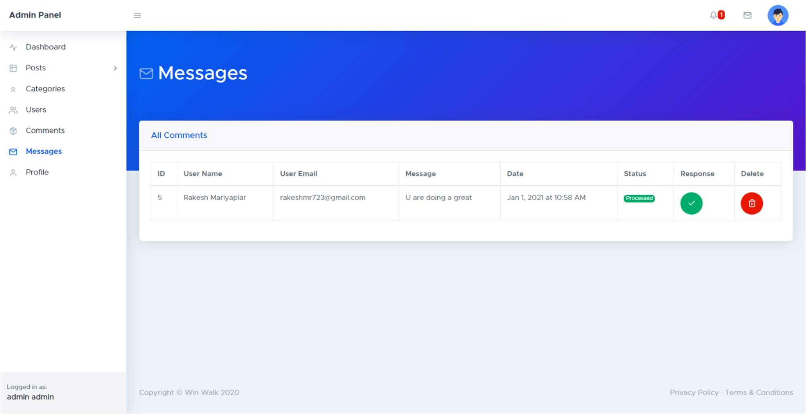

Fig 6.16 All Messages

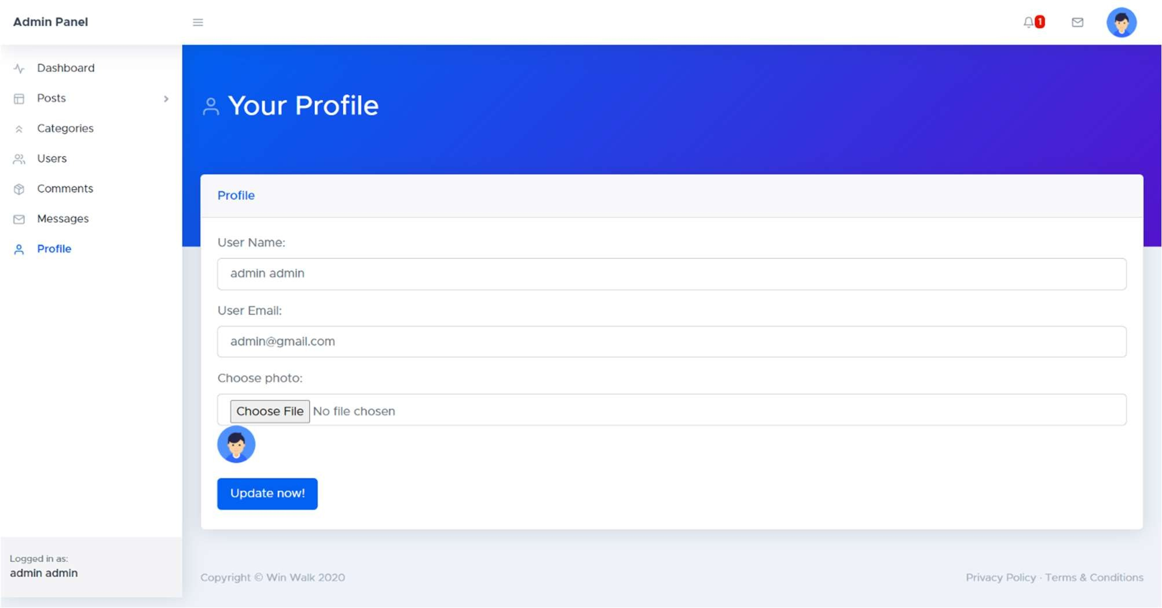

Fig 6.17 Your Profile